Application for Optimized MRP.
MSc. In Enterprise Applications Development.
Enterprise development project.
[Project proposal]
A.L Rajakaruna, pge11-0003
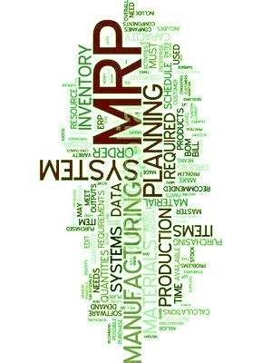

Introduction.

Material requirement Planning (MRP) is the logic for determining the number of parts, components and materials needed to produces a product.[1]
It provides time schedule information specifying when each of the material parts and components should be ordered.[1]
Optimization of the schedule information can be a great advantage over the calculated schedules depending on the various external factors, such as holding cost and procurement costs. This will help various production companies to increase profit and reduce wastes.
The main objective of this project is to develop a MRP application which gives a optimized solution using artificial intelligence technique known to be Genetic algorithms. This method was initially found by D.J Stockton and L.Quinn 1993 under the publication MRP LOT SIZING USING GENETIC ALGORYTHMS.[2]
The application will take advantage over computing power by implementing parallel programming techniques offered by latest programming languages and technologies.

MRP Domain Specific knowledge.

Bill of Material (BOM) Structure
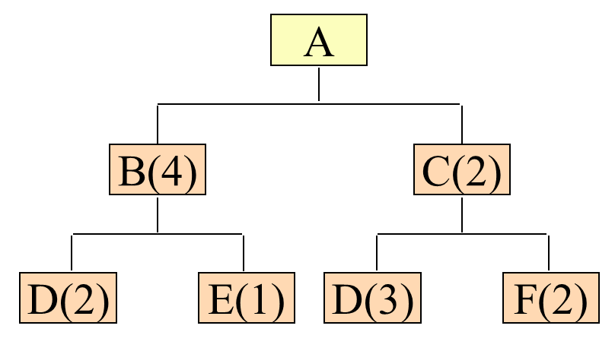
Figure 1

BOM represent dependent parts or materials and amounts to manufacture an end product.

MRP example with stock.
Requirements include 95 units (80 firm orders and 15 forecasts) of X in 10 weeks, plus the following spares ordered:

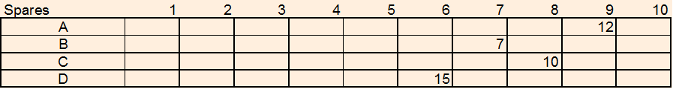
Figure 2

On hand items and lead times.
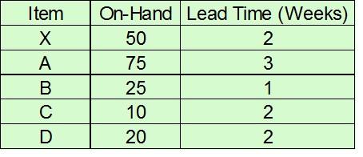
Figure 3

BOM structure.

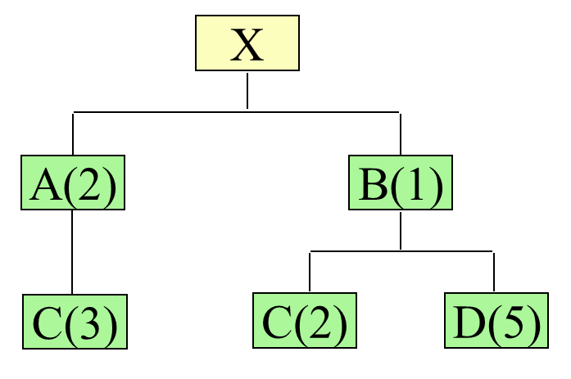
Figure 4

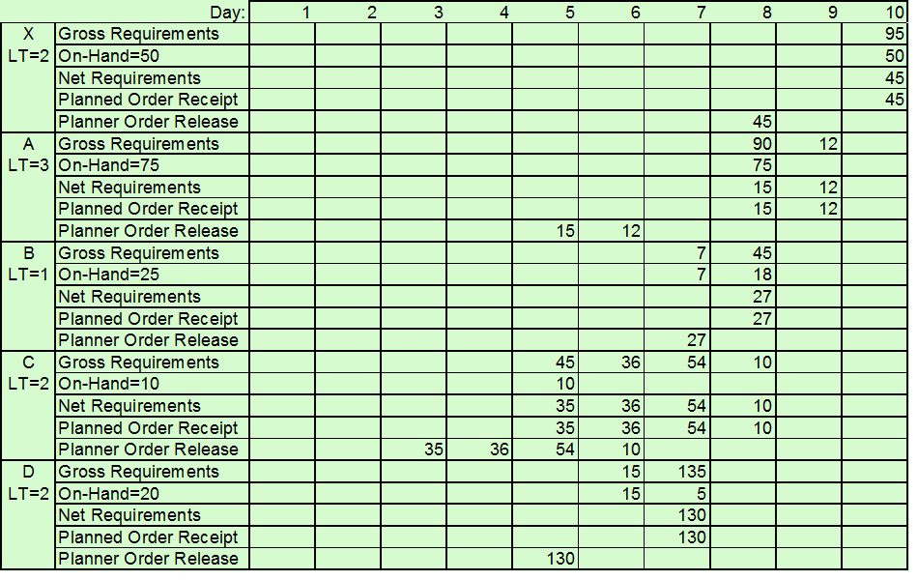
MRP Results.
Figure 5

MRP Optimization
The optimization method mainly intended to be implemented in this project is the use of Genetic algorithms. This method was proposed by D.J Stockton and L.Quinn, De Montfort University under,
MRP LOT SIZING USING GENETIC ALGORYTHMS.[2]
http://www.littoralis.info/iom/secure/assets/1993120121.pdf

Genetic Algorithms
In the computer science field of artificial intelligence, a genetic algorithm is a search heuristic that mimics the process of natural evolution [3]. Genetic Algorithms is a set of procedures which when repeated enables solutions to be found to specific problems. It archives this objective by generating successive populations of alternative solutions until a solution is obtained that yields acceptable or optimal results.

Architecture.
The project chooses to use a client – server web architecture to suit its requirements of scalability and increase usability.

Main Components.
- User Interfaces.
- Data Base to Store Computational data
- MRP Calculations
- Genetic Algorithms execution engine
- Presentation of data as reports.

User Interfaces

BOM data.
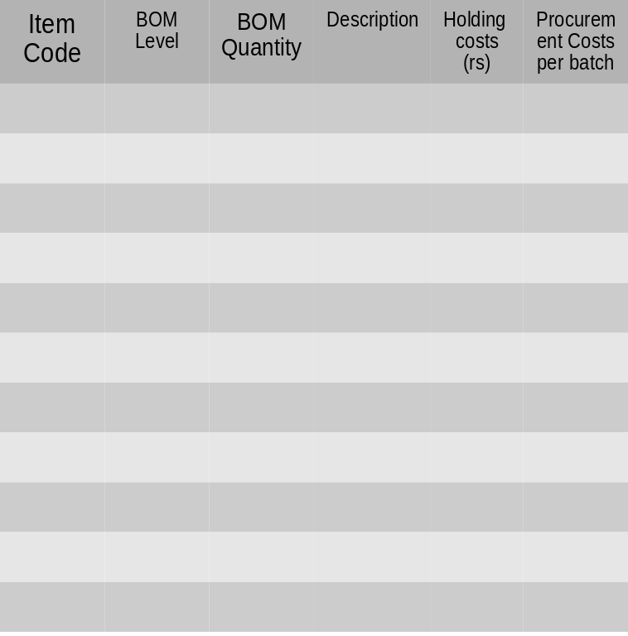
Enter Bill Of Materials for Product
Figure 6

Order plan for product and Spares.

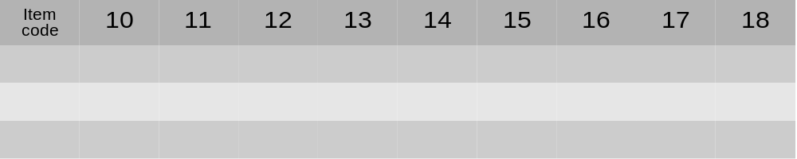
Item code
Select Period
Add to order
Figure 7

Product and Part Details management
  - Query part details
  - Edit part details
Set parameters for Genetic algorithm function.
  - Set Population size
  - Set Fitness function values
    - Storing and Procurement costs functions
  - Set number of Iterations.

Database.
The nature of data to be stored is much relational. MySQL Database would be Ideal for the Implementation.

MRP Process.
The relevant business process related to MRP domain knowledge discussed above will be implemented in the application.

Genetic algorithm execution engine.
- Parallel computing techniques should be tested for better programming solution such as.
  - Actors ( in language Scala /Akka frame work) [5]
  - Map Reduce Algorithms [6].
- Functional programming aspects would help to implement computations parallel.

Presentation of data as reports
The application will generate optimized order schedules which can compare and re- rendered with different parameters.
Reports will be generated from final results which can be viewed as whole.
Results can be stored and quires can be made to view selected data.

Application Architecture.
Spring MVC
Java/Scala Beans

TomCat
Application
Server.
MySql
html
CSS
ajax
jsp
Dispatcher
view
Controller
Business logic
Service
Data access
Database
Figure 8

Technology Stack
- Programing Language used Scala [3].
  - Scala is a hybrid language with Functional and Object Oriented properties.
  - Scala is highly compatible with using java libraries and will run on the JVM.
  - Scala has in built libraries to parallel programming and has Scala Actor framework build to it.
- Default application server used here would be Apache Tomcat. It may be fit to deploy in other Application servers as needed.
- Presentation logic will be generated through HTML or HTML5, CSS ,javascript with jsp.
- Middle tire would be developed using Spring Framework with Scala/java beans.
- Database server MySQL.

Project Plan.

Work Breakdown structure (WBS).
1.1 Create project blog
1.2 Set up SVN
1.3 Project environment
1.4 Development tools
2.1 BOM interface
2.2 Order interface
2.3 Product detail
2.4 Genetic param
2.1.1 BOM Tree
2.1.2 BOM Validations
1.3.1 Application Server
1.1 Set up database
1.4.1 Eclips IDE
3.1 Generate MRP
3.2 In/out Services
3.1.1MRP Data structure
3.1.2 Business logic
1.4.2 Create Project
3.1.1.1 BOM Data
3.1.1.2 MRP Solution
2.2 .1 input Order
2.2 .2 Cost functions
3.1.2.1 Validate BOM
3.1.2.2 Cost functions
1.Project Setup
2) User Interfaces
3) MRP

4)Genetic Algorithm
5) Database
6) Reports
4.1 Data structure Gene
4.2 Encode binary
4.3 Decode Binary
4.4 Population functions
4.5 Random Solutions
5.1 BOM
5.2 Orders
5.3 Save MRP
3.1 Generate MRP
6.2 Export Reports
4.4.1 test fitness
4.4.2 Gene crossover
4.6 Parallel processing
Figure 9

Note: detail WBS is attached with a Microsoft project file (.mpp) attached to this document.

Project plan.

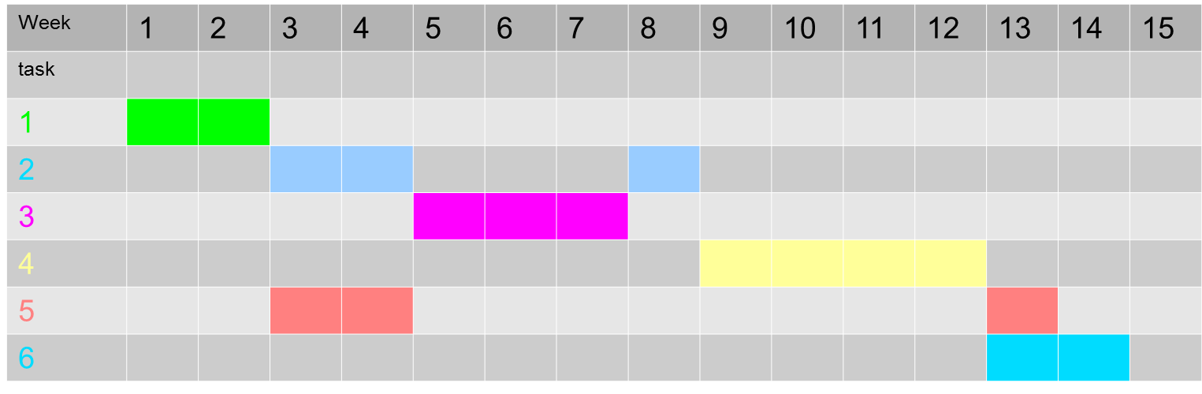
Figure 10

Note: Detail Gantt chart is attached with a Microsoft project file (.mpp) attached to this document.

The project schedule and archiving milestones are planned for the available development weeks as above.
The project development will commence from 11th of August 2012 and planned delivery date is 24th of November 2012. One week is taken to be 15-20 effective hours of development.
Components which are assumed to have more critical thinking were allocated more time.
Final week is for packaging the software for delivery. This will include final system testing and fixing bugs if prevails.

Attachments.
pge11-0003 EDP project Plan.mpp

Summary.
The main motivation of this project is to build a solution for MRP with optimized lot sizing using Genetic Algorithms and parallel processing.
To archive this, model proposed by D.J Stockton and L.Quinn will be implemented.
In implementation, latest and emerging technology such as Scala programming language and parallel programming techniques will be used.

Bibliography.

[1] “Ch16-MRP Ppt Presentation.” [Online]. Available: http://www.authorstream.com/Presentation/piyoosh-1464398-ch16-mrp/. [Accessed: 03-Aug-2012].
[2] L. Q. D.J Stockton, “MRP Lot Sizing Using Genetic Algorithms,” BPICS CONTROL, 1993..
[3] “Genetic Algorithms.” [Online]. Available: http://www.doc.ic.ac.uk/~nd/surprise_96/journal/vol4/tcw2/report.html. [Accessed: 02-Aug-2012].

[4]“The Scala Programming Language.” [Online]. Available: http://www.scala-lang.org/. [Accessed: 02-Aug-2012].

[5] “Scala Actors 101 - Threadless and Scalable | Javalobby.” [Online]. Available: http://java.dzone.com/articles/scala-threadless-concurrent. [Accessed: 02-Aug-2012].

[6] “Introduction to Parallel Programming and MapReduce - Google Code University - Google Code.” [Online]. Available: http://code.google.com/edu/parallel/mapreduce-tutorial.html. [Accessed: 02-Aug-2012].

